Creating and using database (schema):

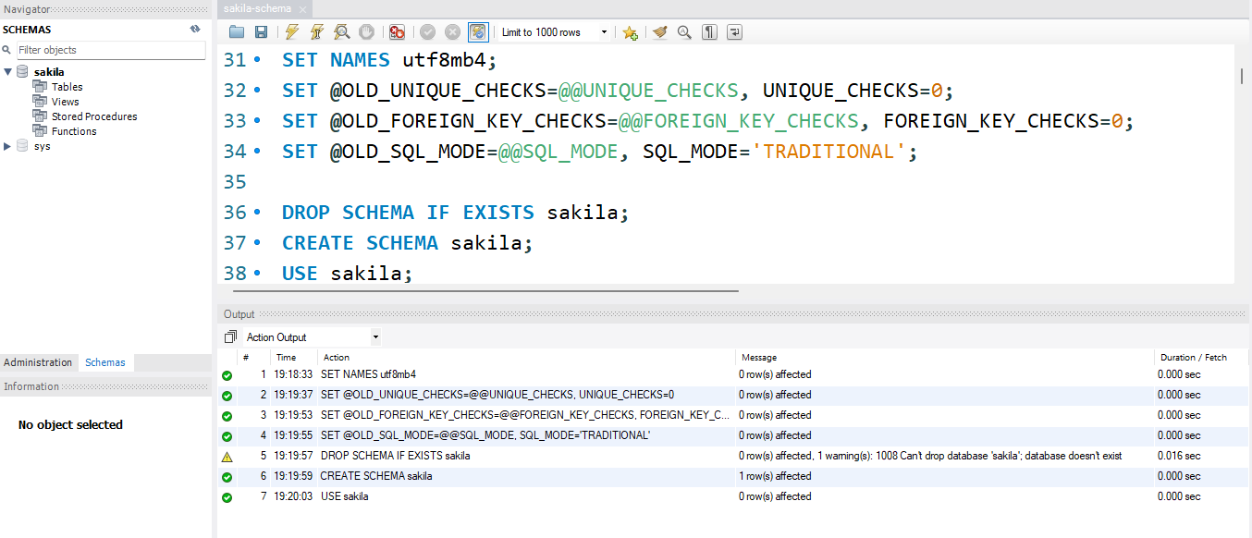

Creating table “actor”:

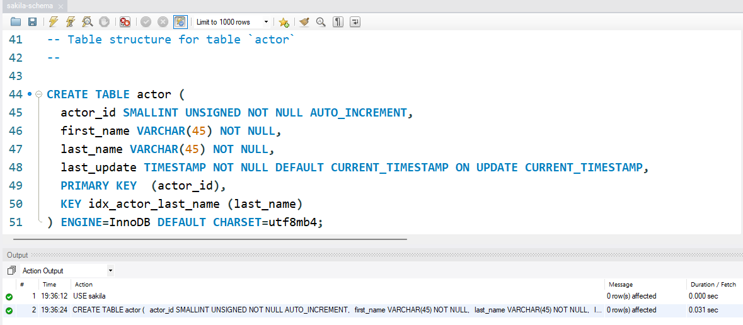

Creating table “address”:

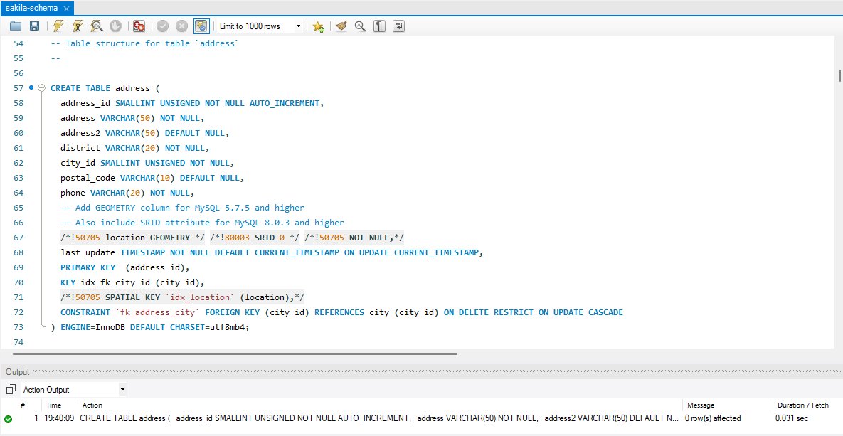

Creating table “category”:

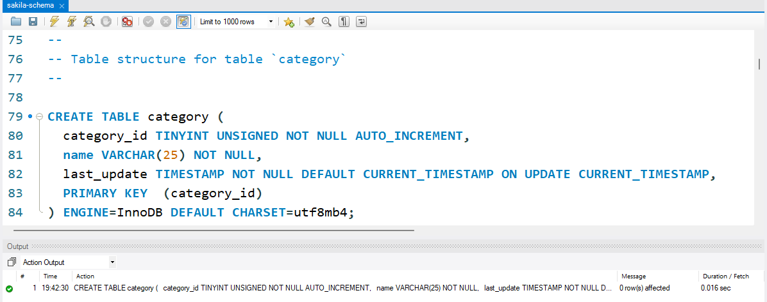

Creating table “city”:

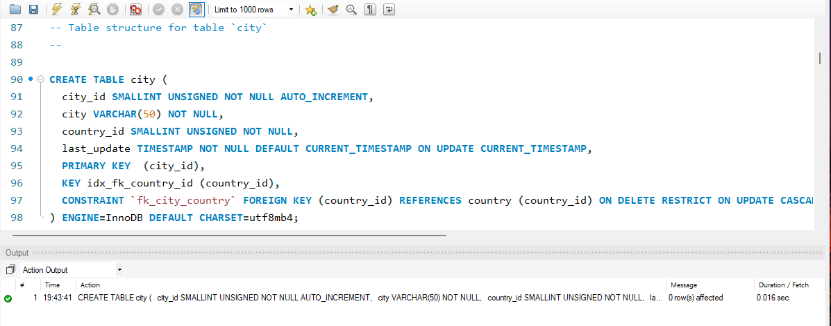

Creating table “country”:

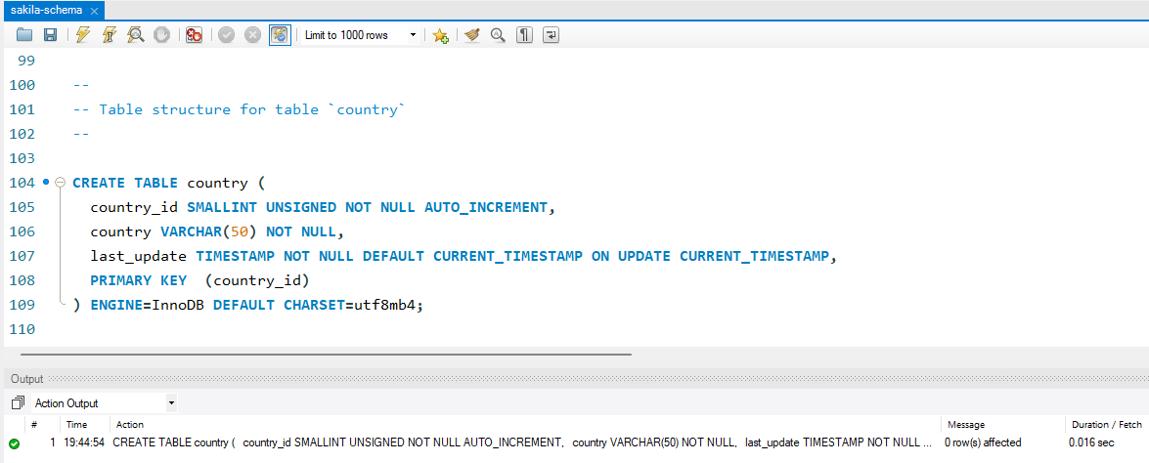

Creating table “customer”:

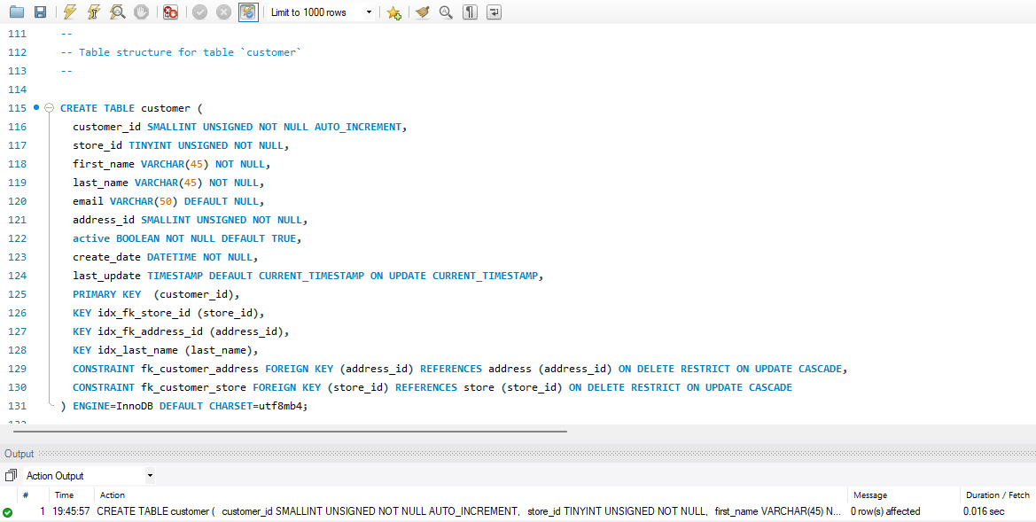

Creating table “film”:

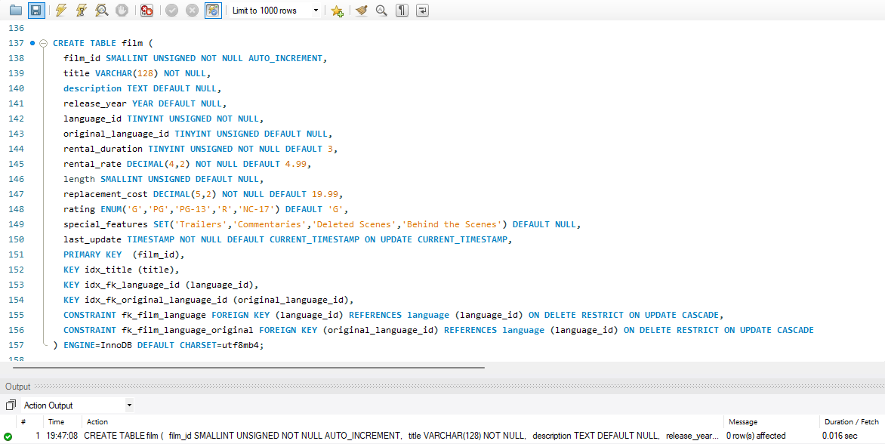

Create table “film_actor”:

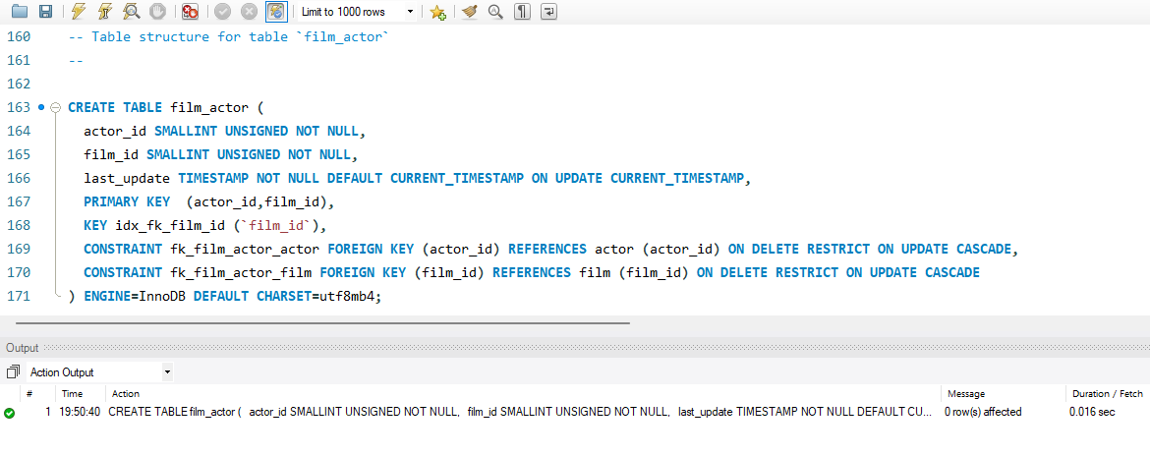

Create table “film_category”:

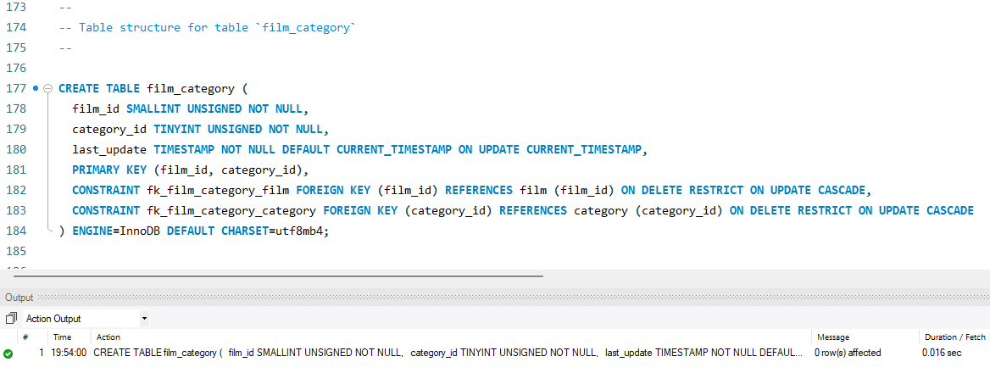

Use InnoDB for film_text as of 5.6.10, MyISAM prior to 5.6.10.

Create table “film_text”:

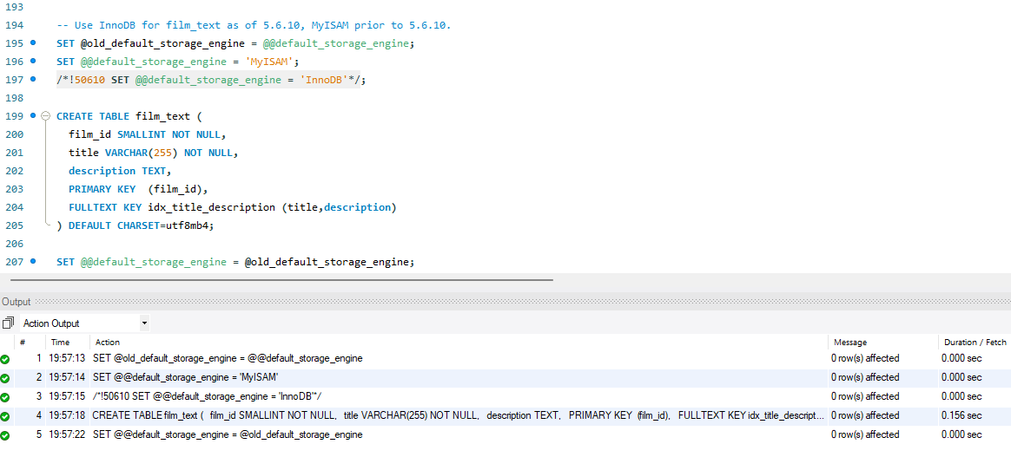

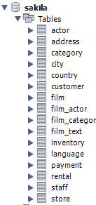

Triggers for loading film_text from film:

Creating trigger `ins_film`:

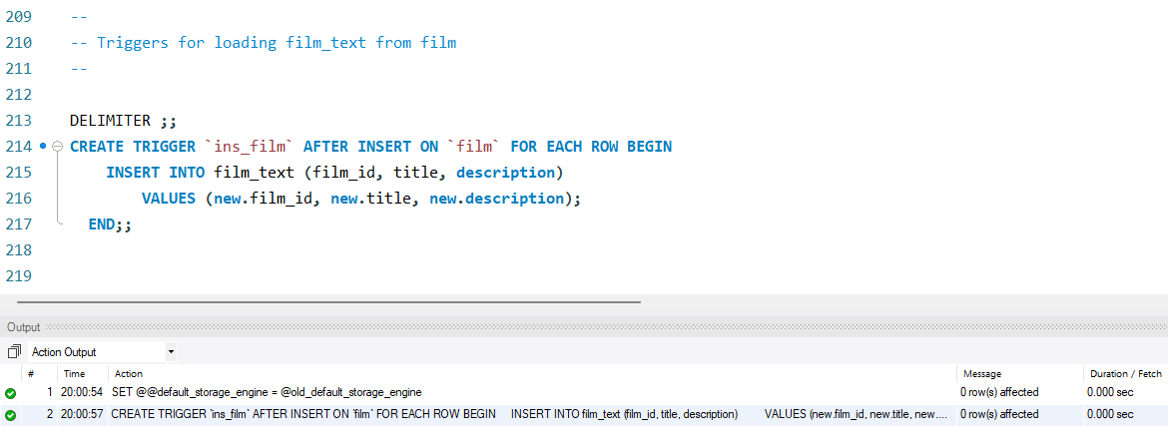

Creating trigger `upd_film`:

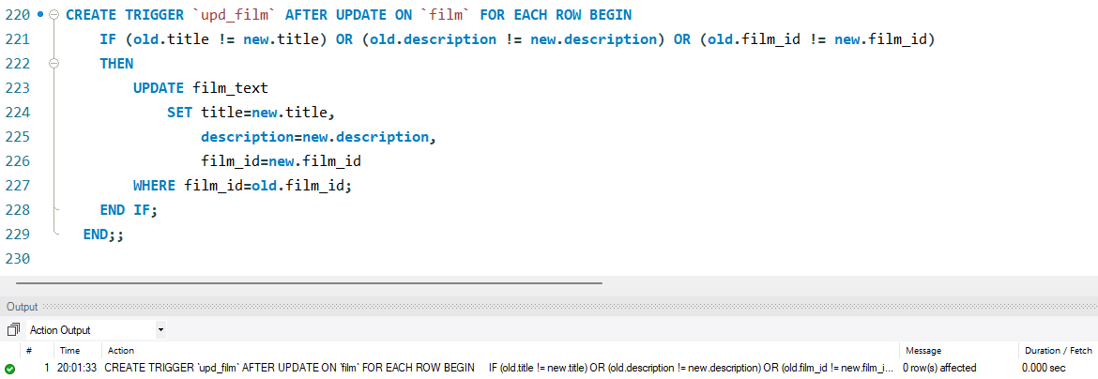

Creating trigger `del_film`:

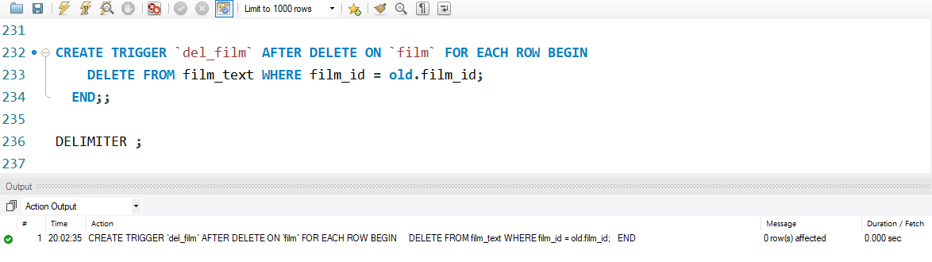

Creating table “inventory”:

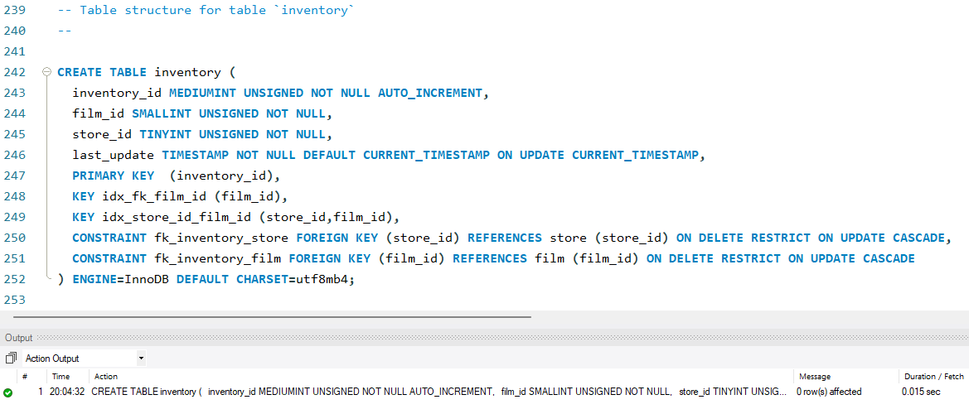

Create table “language”:

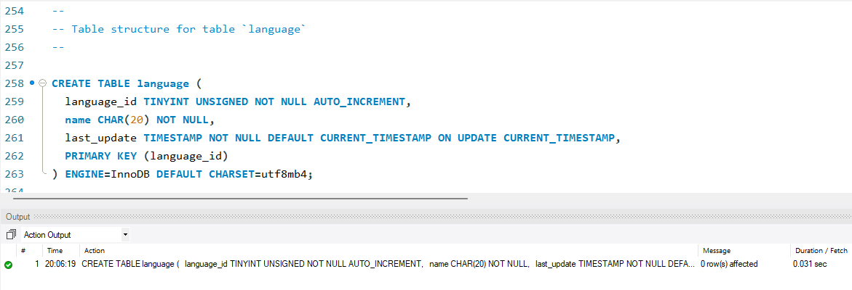

Create table “payment”:

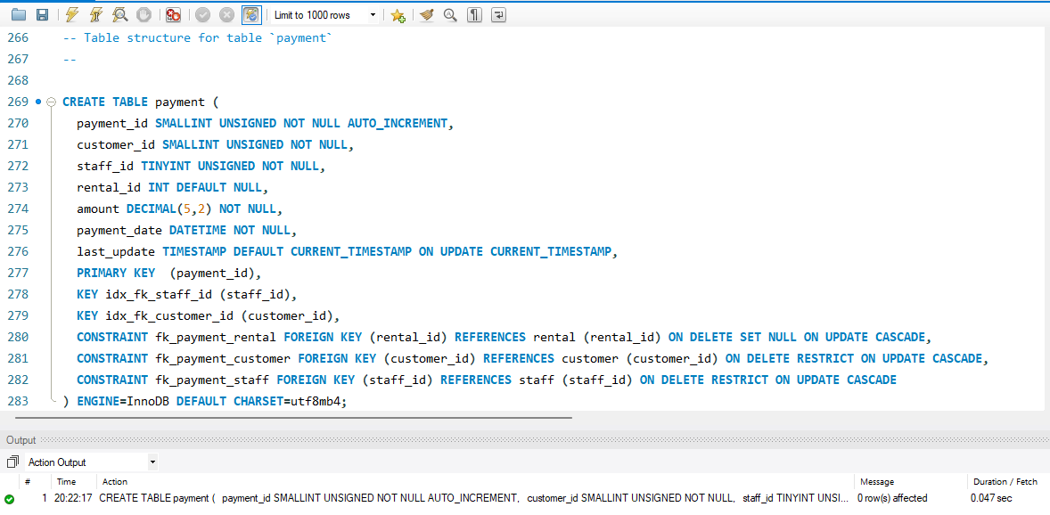

Create table “rental”:

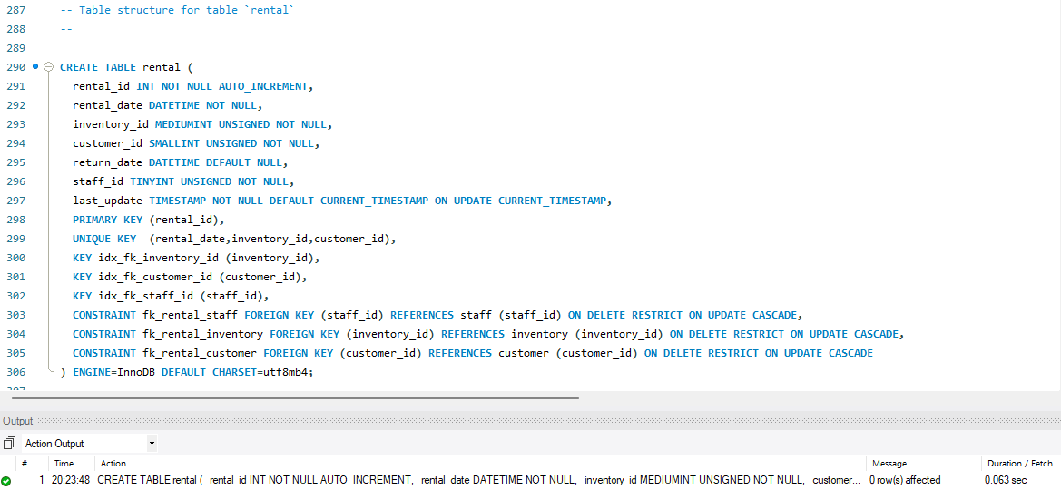

Create table “staff”:

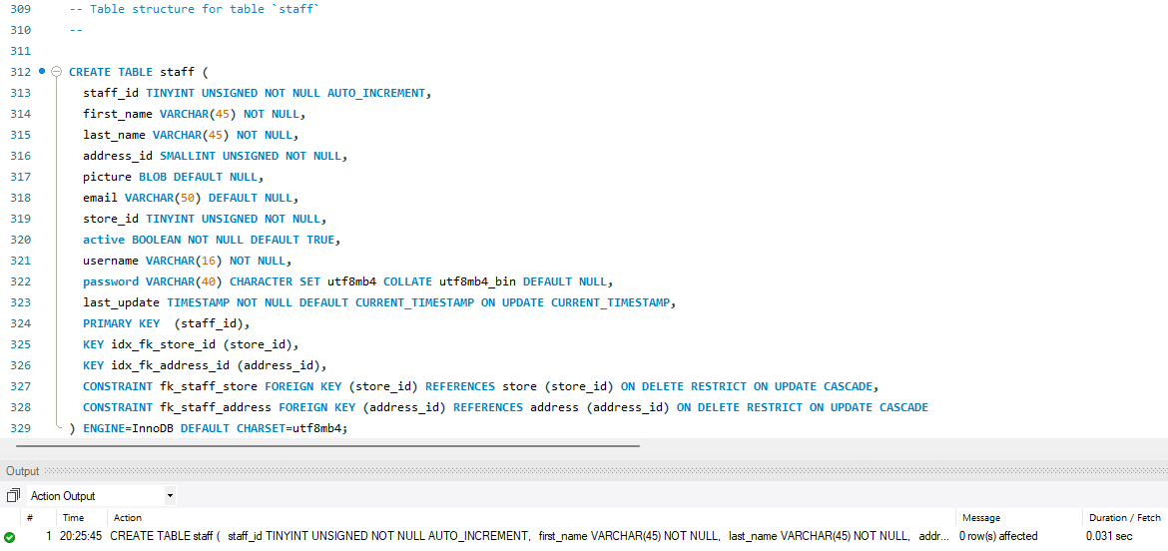

Create table “store”:

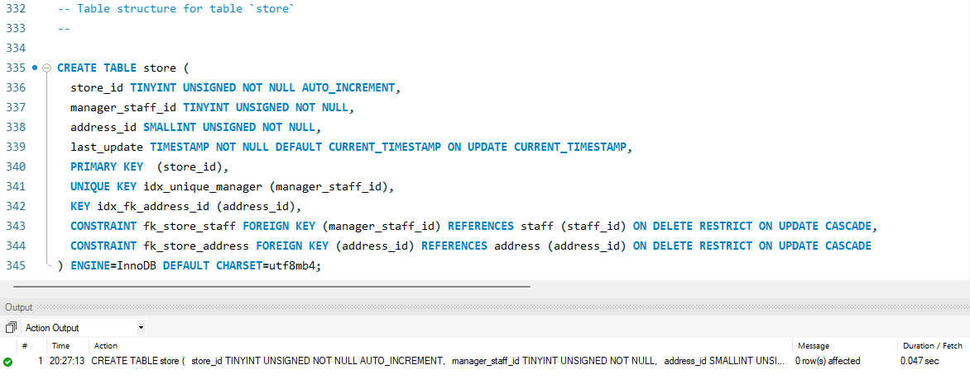

View structure for view “customer_list”:

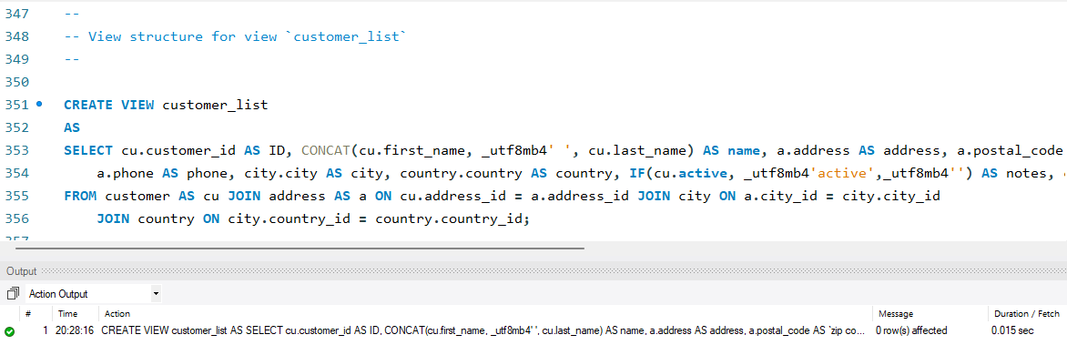

View structure for view “film_list”:

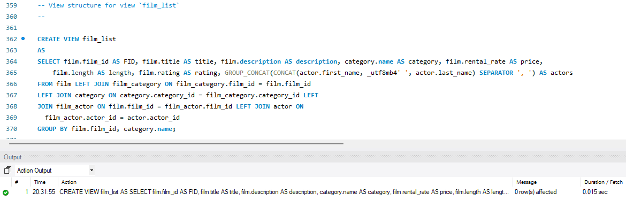

View structure for view “Nicer_but_slower_film_list”:

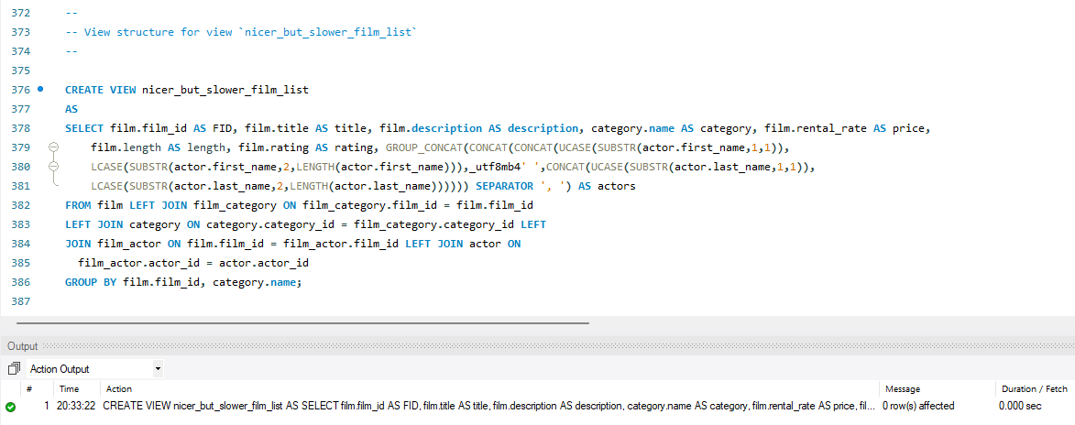

View structure for view “staff_list”:

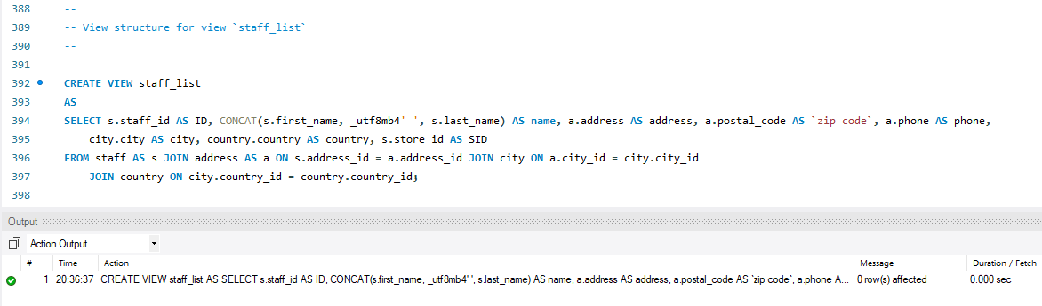

View structure for view “sales_by_store”:

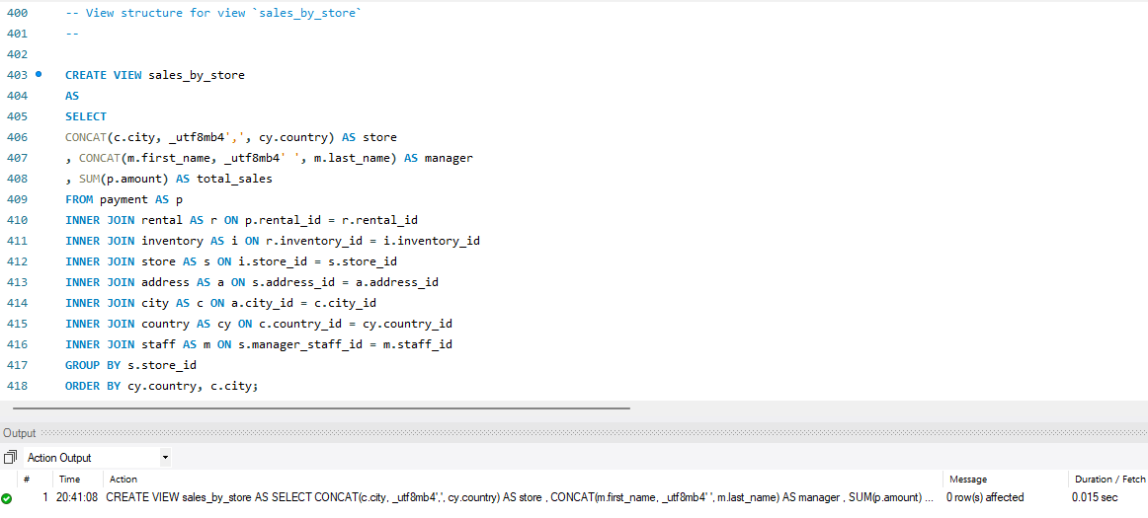

View structure for view “sales_by_film_category”:

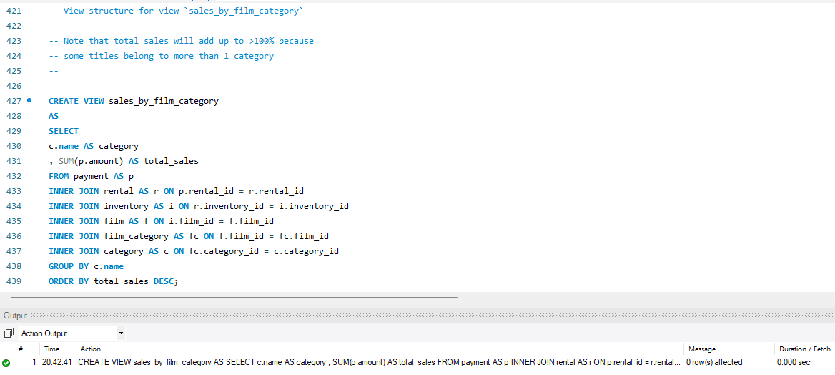

Creating view structure for view “actor_info”:

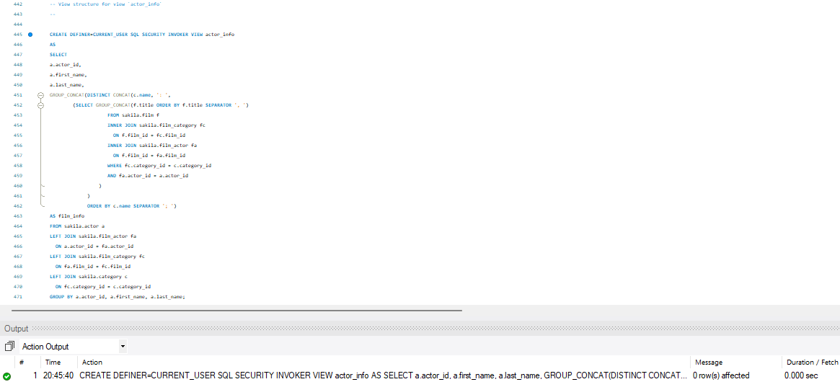

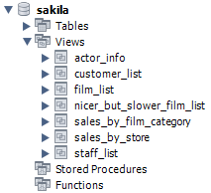

Procedure structures:

--

-- Procedure structure for procedure `rewards_report`

--

DELIMITER //

CREATE PROCEDURE rewards_report (

IN min_monthly_purchases TINYINT UNSIGNED

, IN min_dollar_amount_purchased DECIMAL(10,2)

, OUT count_rewardees INT

)

LANGUAGE SQL

NOT DETERMINISTIC

READS SQL DATA

SQL SECURITY DEFINER

COMMENT 'Provides a customizable report on best customers'

proc: BEGIN

DECLARE last_month_start DATE;

DECLARE last_month_end DATE;

/* Some sanity checks... */

IF min_monthly_purchases = 0 THEN

SELECT 'Minimum monthly purchases parameter must be > 0';

LEAVE proc;

END IF;

IF min_dollar_amount_purchased = 0.00 THEN

SELECT 'Minimum monthly dollar amount purchased parameter must be > $0.00';

LEAVE proc;

END IF;

/* Determine start and end time periods */

SET last_month_start = DATE_SUB(CURRENT_DATE(), INTERVAL 1 MONTH);

SET last_month_start = STR_TO_DATE(CONCAT(YEAR(last_month_start),'-',MONTH(last_month_start),'-01'),'%Y-%m-%d');

SET last_month_end = LAST_DAY(last_month_start);

/*

Create a temporary storage area for

Customer IDs.

*/

CREATE TEMPORARY TABLE tmpCustomer (customer_id SMALLINT UNSIGNED NOT NULL PRIMARY KEY);

/*

Find all customers meeting the

monthly purchase requirements

*/

INSERT INTO tmpCustomer (customer_id)

SELECT p.customer_id

FROM payment AS p

WHERE DATE(p.payment_date) BETWEEN last_month_start AND last_month_end

GROUP BY customer_id

HAVING SUM(p.amount) > min_dollar_amount_purchased

AND COUNT(customer_id) > min_monthly_purchases;

/* Populate OUT parameter with count of found customers */

SELECT COUNT(*) FROM tmpCustomer INTO count_rewardees;

/*

Output ALL customer information of matching rewardees.

Customize output as needed.

*/

SELECT c.*

FROM tmpCustomer AS t

INNER JOIN customer AS c ON t.customer_id = c.customer_id;

/* Clean up */

DROP TABLE tmpCustomer;

END //

DELIMITER ;

DELIMITER $$

CREATE FUNCTION get_customer_balance(p_customer_id INT, p_effective_date DATETIME) RETURNS DECIMAL(5,2)

DETERMINISTIC

READS SQL DATA

BEGIN

#OK, WE NEED TO CALCULATE THE CURRENT BALANCE GIVEN A CUSTOMER_ID AND A DATE

#THAT WE WANT THE BALANCE TO BE EFFECTIVE FOR. THE BALANCE IS:

# 1) RENTAL FEES FOR ALL PREVIOUS RENTALS

# 2) ONE DOLLAR FOR EVERY DAY THE PREVIOUS RENTALS ARE OVERDUE

# 3) IF A FILM IS MORE THAN RENTAL_DURATION * 2 OVERDUE, CHARGE THE REPLACEMENT_COST

# 4) SUBTRACT ALL PAYMENTS MADE BEFORE THE DATE SPECIFIED

DECLARE v_rentfees DECIMAL(5,2); #FEES PAID TO RENT THE VIDEOS INITIALLY

DECLARE v_overfees INTEGER; #LATE FEES FOR PRIOR RENTALS

DECLARE v_payments DECIMAL(5,2); #SUM OF PAYMENTS MADE PREVIOUSLY

SELECT IFNULL(SUM(film.rental_rate),0) INTO v_rentfees

FROM film, inventory, rental

WHERE film.film_id = inventory.film_id

AND inventory.inventory_id = rental.inventory_id

AND rental.rental_date <= p_effective_date

AND rental.customer_id = p_customer_id;

SELECT IFNULL(SUM(IF((TO_DAYS(rental.return_date) - TO_DAYS(rental.rental_date)) > film.rental_duration,

((TO_DAYS(rental.return_date) - TO_DAYS(rental.rental_date)) - film.rental_duration),0)),0) INTO v_overfees

FROM rental, inventory, film

WHERE film.film_id = inventory.film_id

AND inventory.inventory_id = rental.inventory_id

AND rental.rental_date <= p_effective_date

AND rental.customer_id = p_customer_id;

SELECT IFNULL(SUM(payment.amount),0) INTO v_payments

FROM payment

WHERE payment.payment_date <= p_effective_date

AND payment.customer_id = p_customer_id;

RETURN v_rentfees + v_overfees - v_payments;

END $$

DELIMITER ;

DELIMITER $$

CREATE PROCEDURE film_in_stock(IN p_film_id INT, IN p_store_id INT, OUT p_film_count INT)

READS SQL DATA

BEGIN

SELECT inventory_id

FROM inventory

WHERE film_id = p_film_id

AND store_id = p_store_id

AND inventory_in_stock(inventory_id);

SELECT COUNT(*)

FROM inventory

WHERE film_id = p_film_id

AND store_id = p_store_id

AND inventory_in_stock(inventory_id)

INTO p_film_count;

END $$

DELIMITER ;

DELIMITER $$

CREATE PROCEDURE film_not_in_stock(IN p_film_id INT, IN p_store_id INT, OUT p_film_count INT)

READS SQL DATA

BEGIN

SELECT inventory_id

FROM inventory

WHERE film_id = p_film_id

AND store_id = p_store_id

AND NOT inventory_in_stock(inventory_id);

SELECT COUNT(*)

FROM inventory

WHERE film_id = p_film_id

AND store_id = p_store_id

AND NOT inventory_in_stock(inventory_id)

INTO p_film_count;

END $$

DELIMITER ;

DELIMITER $$

CREATE FUNCTION inventory_held_by_customer(p_inventory_id INT) RETURNS INT

READS SQL DATA

BEGIN

DECLARE v_customer_id INT;

DECLARE EXIT HANDLER FOR NOT FOUND RETURN NULL;

SELECT customer_id INTO v_customer_id

FROM rental

WHERE return_date IS NULL

AND inventory_id = p_inventory_id;

RETURN v_customer_id;

END $$

DELIMITER ;

DELIMITER $$

CREATE FUNCTION inventory_in_stock(p_inventory_id INT) RETURNS BOOLEAN

READS SQL DATA

BEGIN

DECLARE v_rentals INT;

DECLARE v_out INT;

#AN ITEM IS IN-STOCK IF THERE ARE EITHER NO ROWS IN THE rental TABLE

#FOR THE ITEM OR ALL ROWS HAVE return_date POPULATED

SELECT COUNT(*) INTO v_rentals

FROM rental

WHERE inventory_id = p_inventory_id;

IF v_rentals = 0 THEN

RETURN TRUE;

END IF;

SELECT COUNT(rental_id) INTO v_out

FROM inventory LEFT JOIN rental USING(inventory_id)

WHERE inventory.inventory_id = p_inventory_id

AND rental.return_date IS NULL;

IF v_out > 0 THEN

RETURN FALSE;

ELSE

RETURN TRUE;

END IF;

END $$

DELIMITER ;

SET SQL_MODE=@OLD_SQL_MODE;

SET FOREIGN_KEY_CHECKS=@OLD_FOREIGN_KEY_CHECKS;

SET UNIQUE_CHECKS=@OLD_UNIQUE_CHECKS;

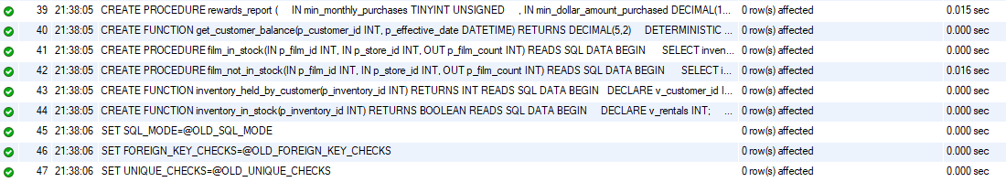



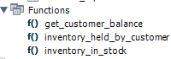

Populating the tables:

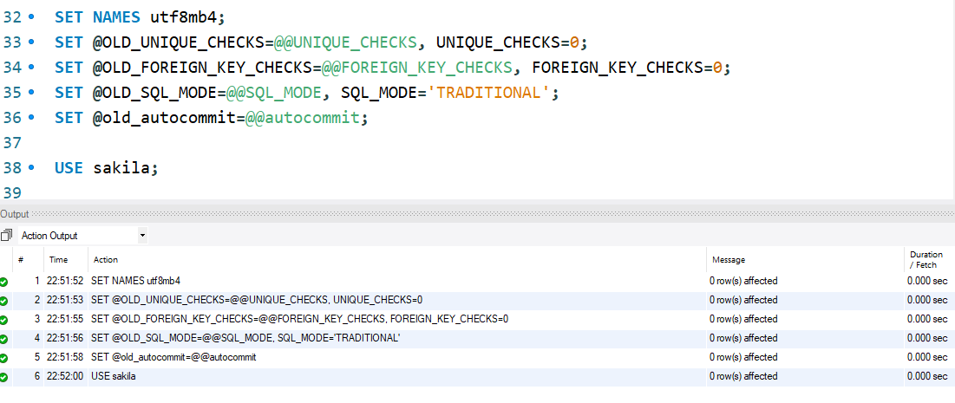

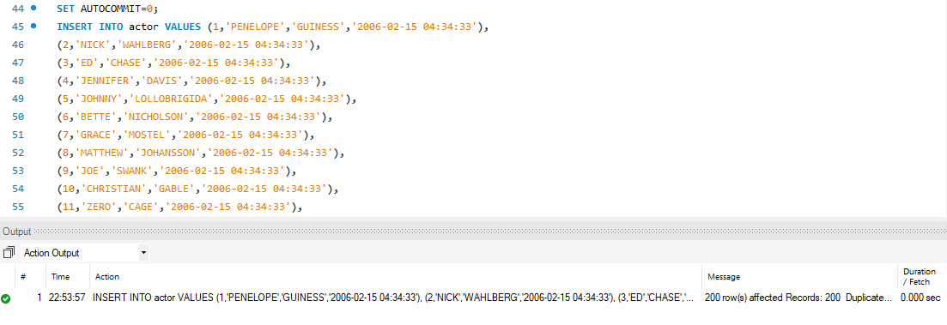

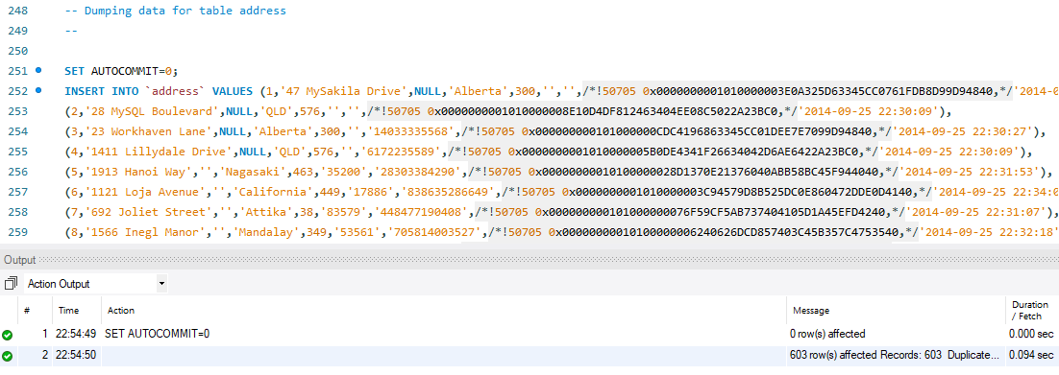

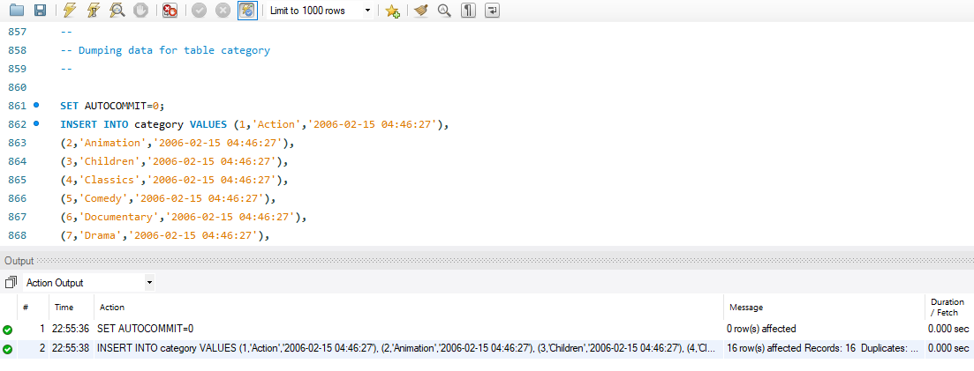

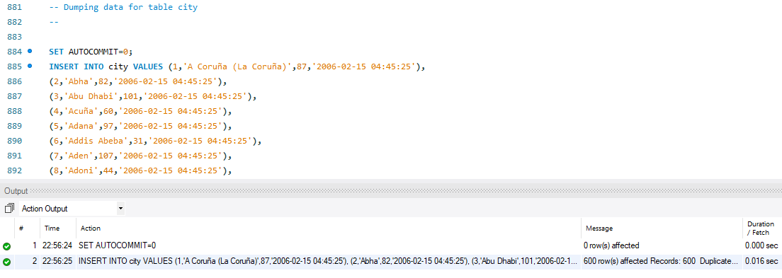

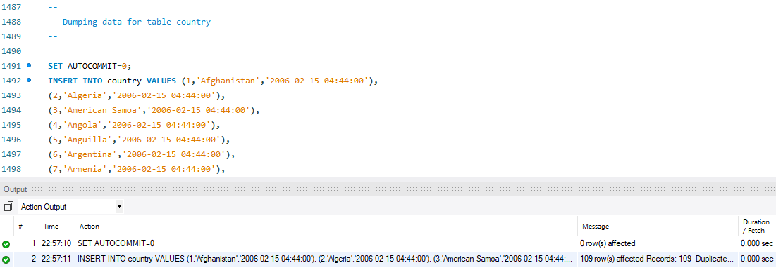

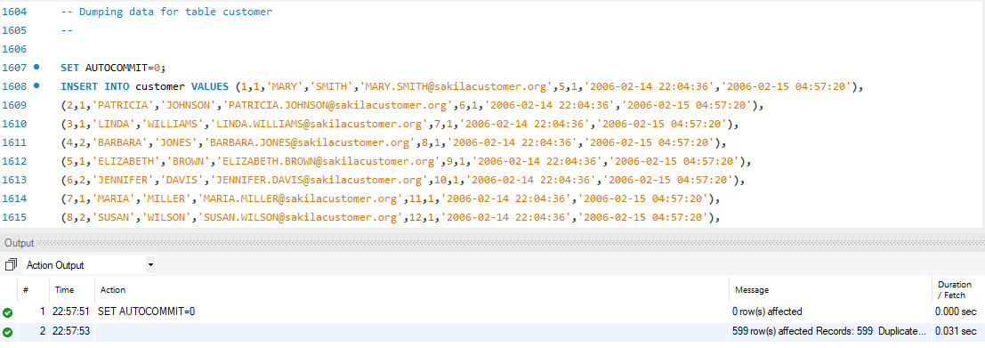

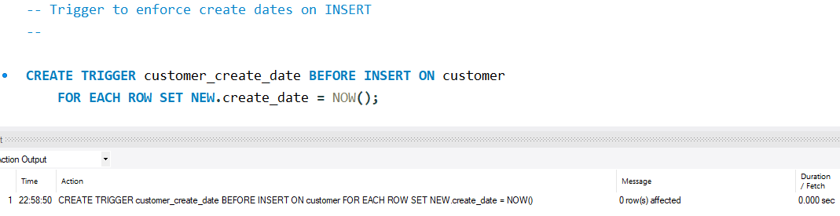

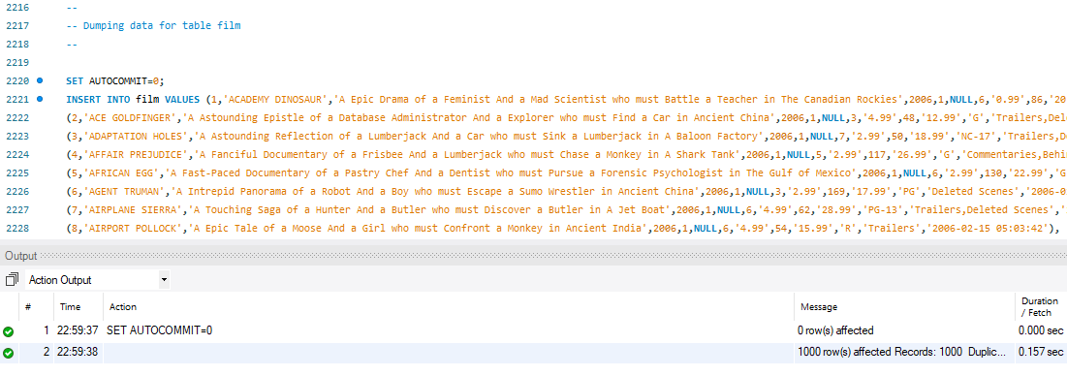

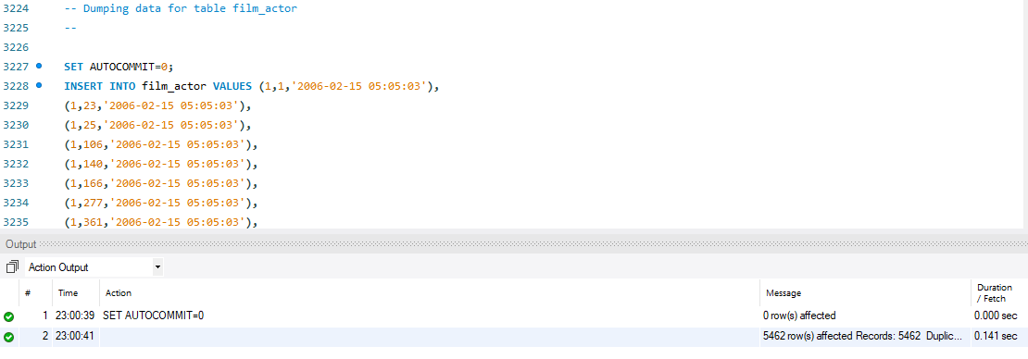

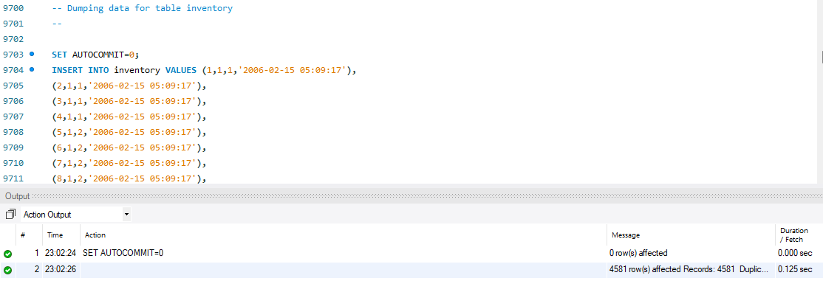

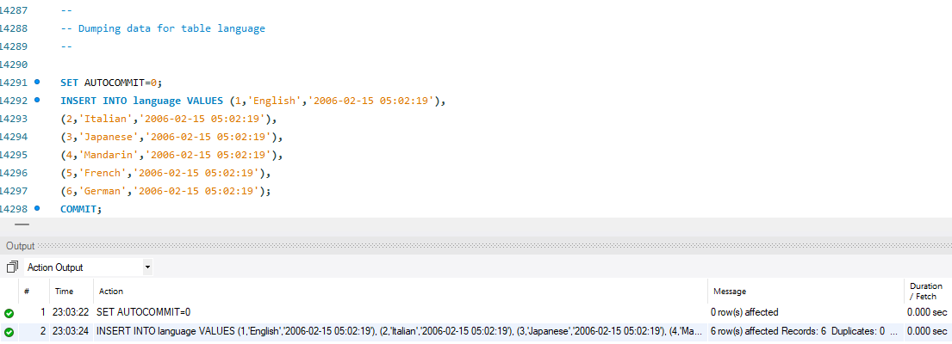

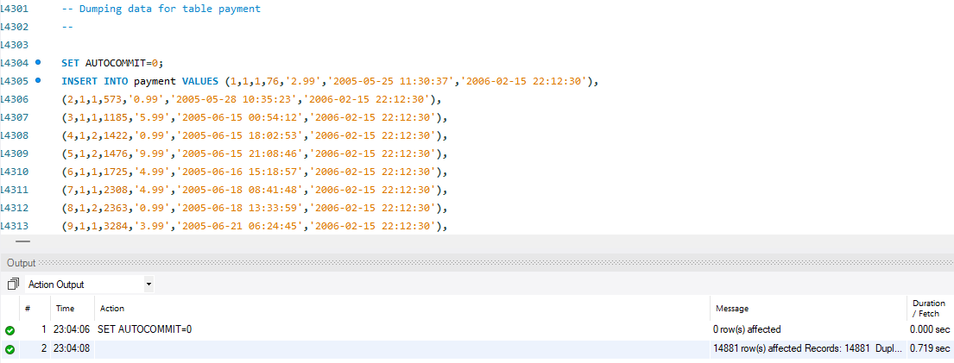

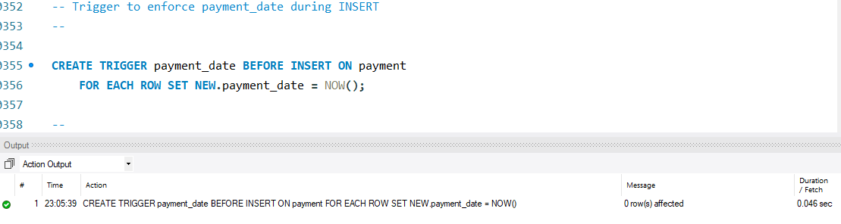

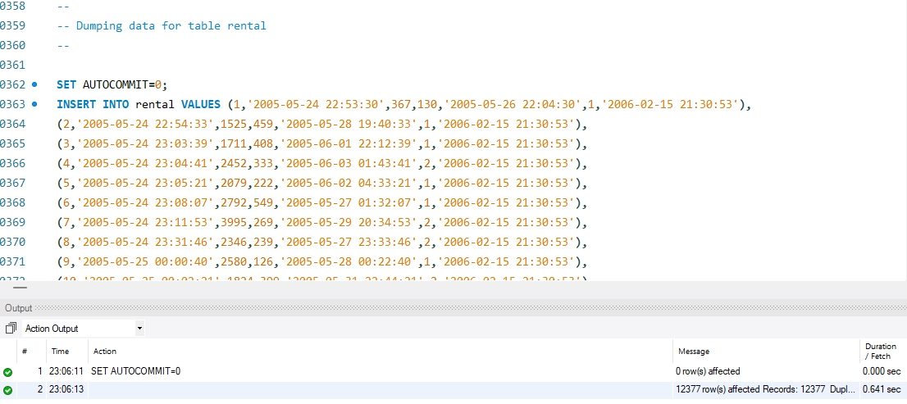

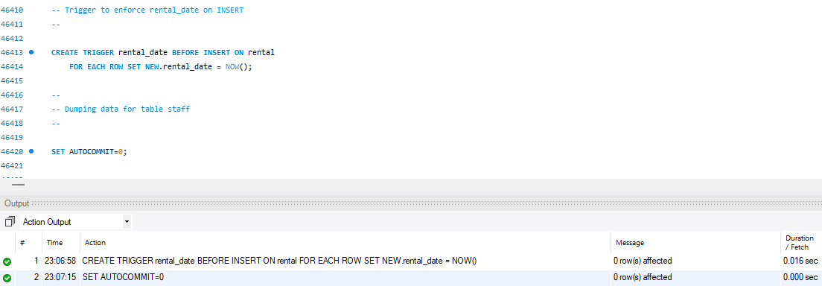

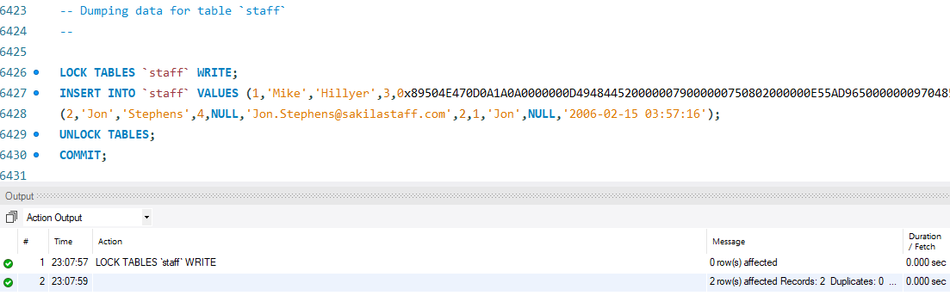

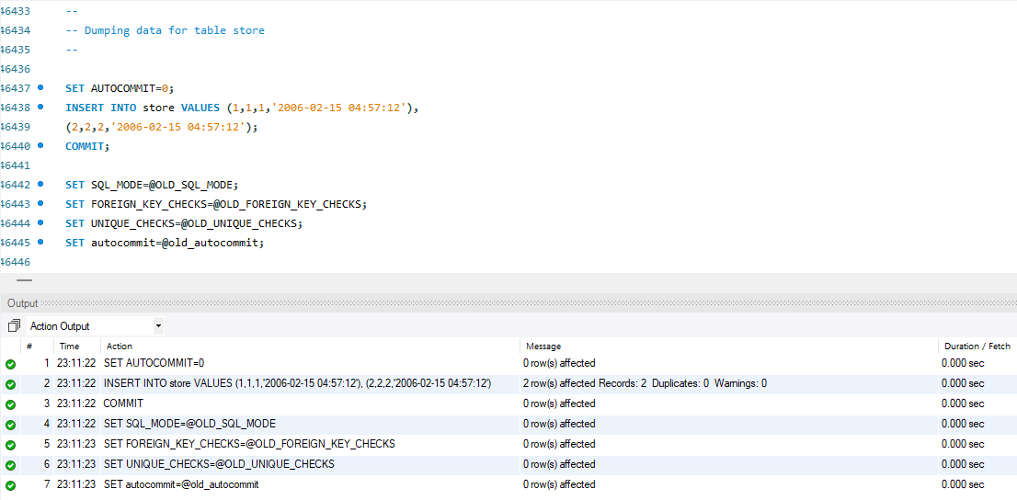

Solutions:

1. What is the most watched film (number of rentals) by each category?

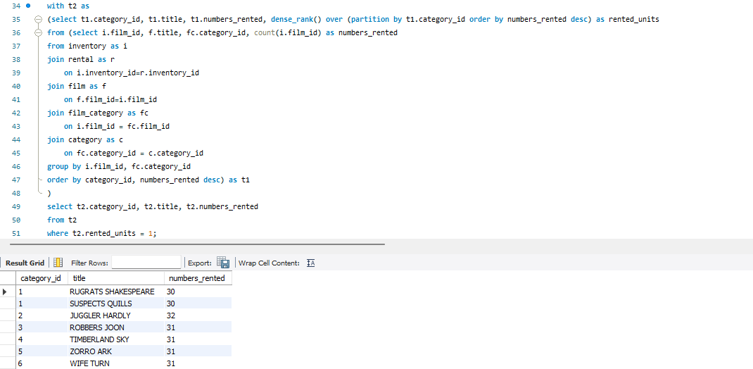

1. What is the total rental amount per category?

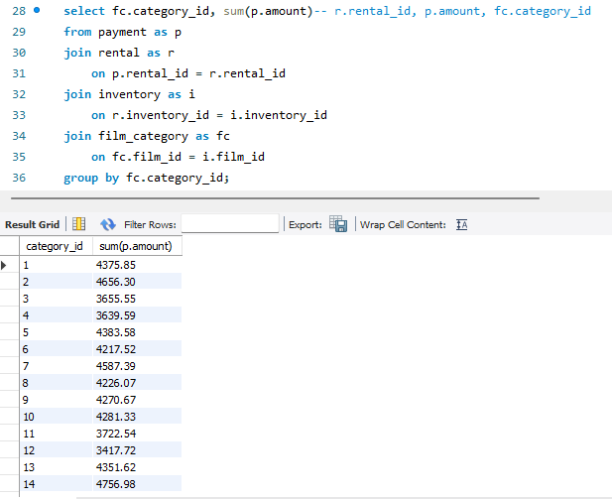

1. For each category, list the customer who is the second most renter.

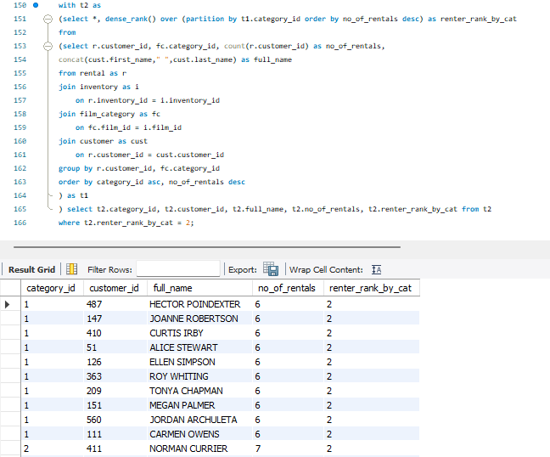

1. What is the second most popular movie title?

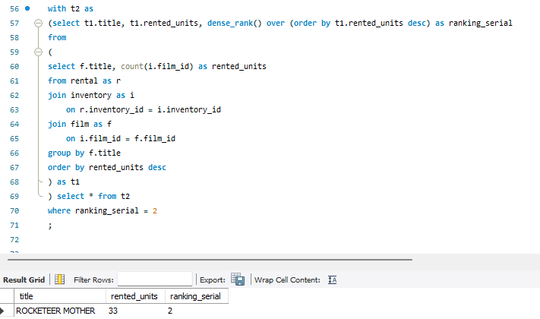

1. What are the most popular categories?

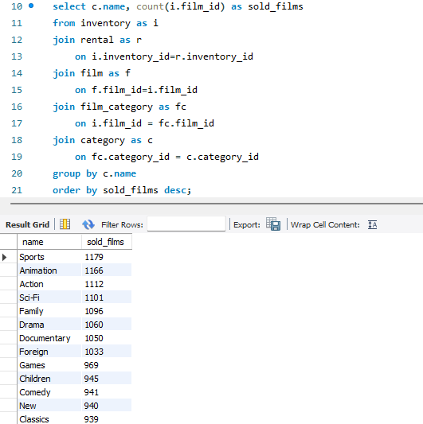

1. What are the top 10 most rented movies by category?

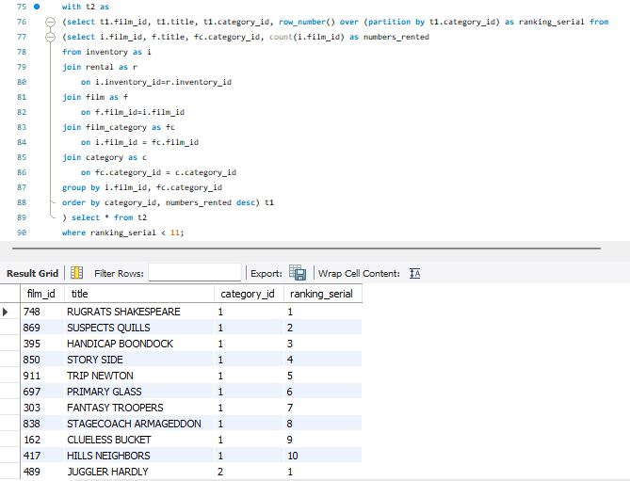

1. What are the average rental days for each movie?

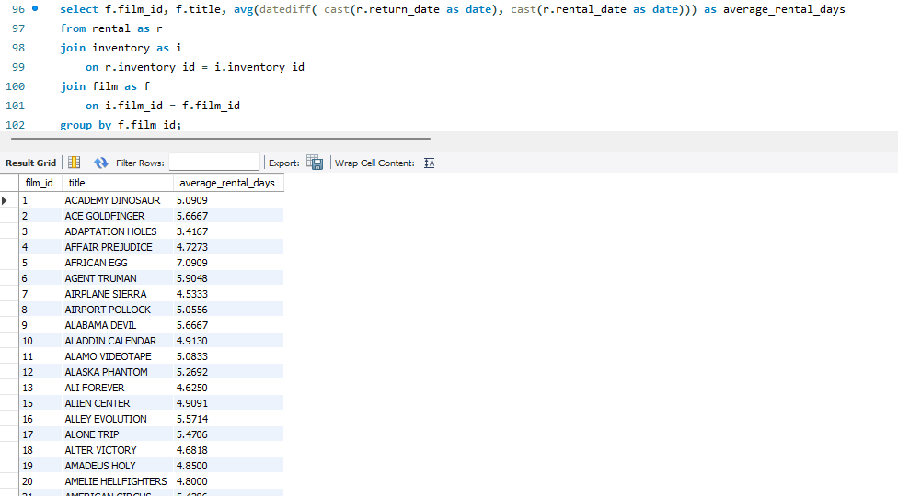

1. What are the top 10 most rented movies by day of the week?

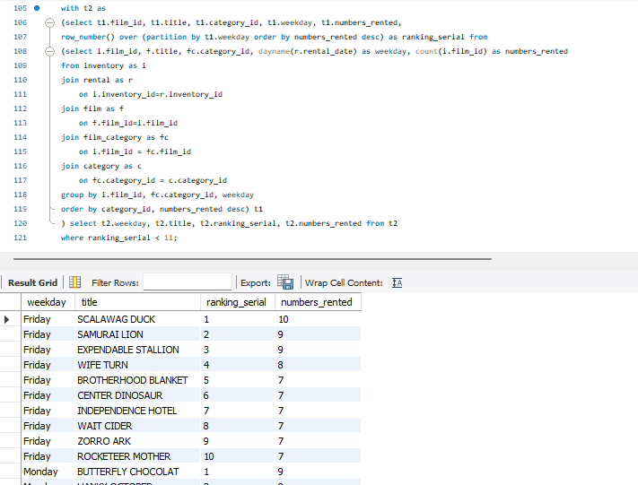

1. What is the total rental revenue (total amount of all rentals) by day of the week?

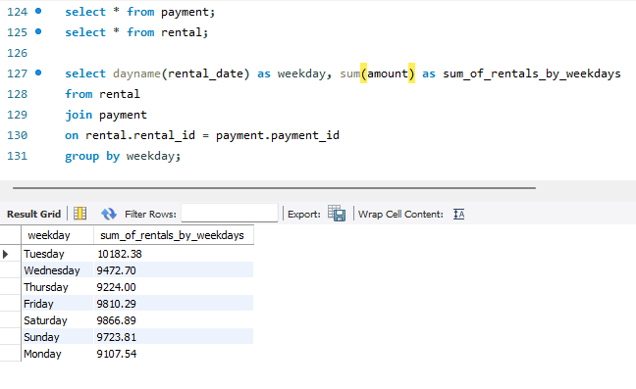

1. What are the most popular movies for each reward tier (rating)?

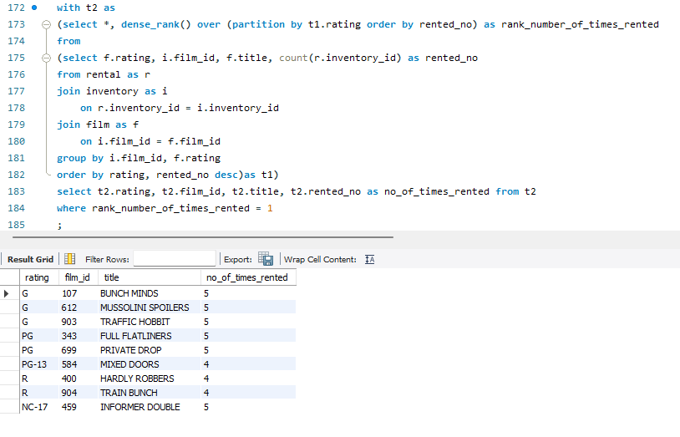

1. What are the average rental days by reward tier (rating)?

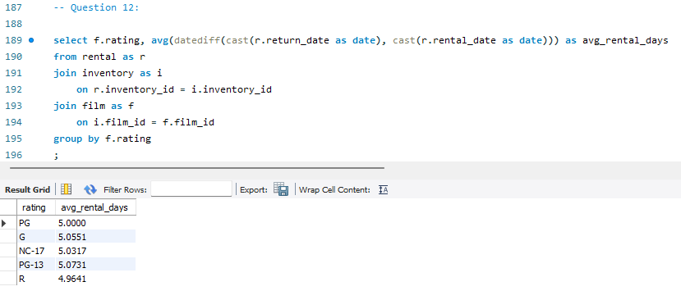

1. What are the most popular days to rent movies?

By date

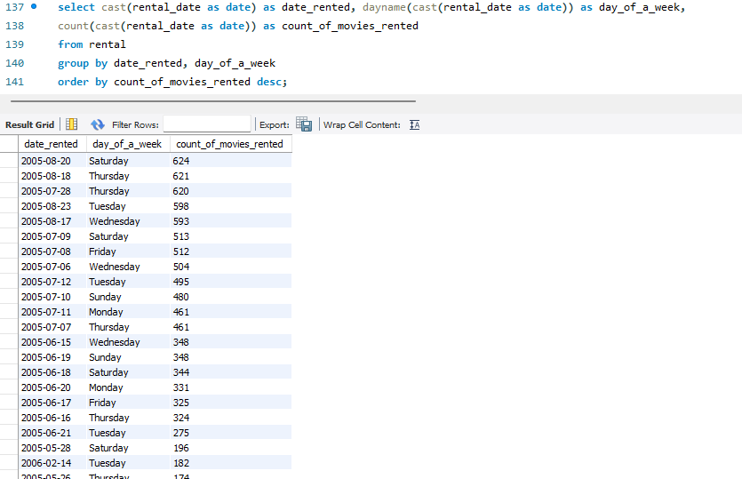

By weekday

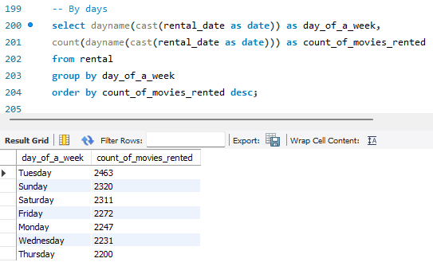

1. What are the most popular days to rent movies by reward tier (rating)?

By date

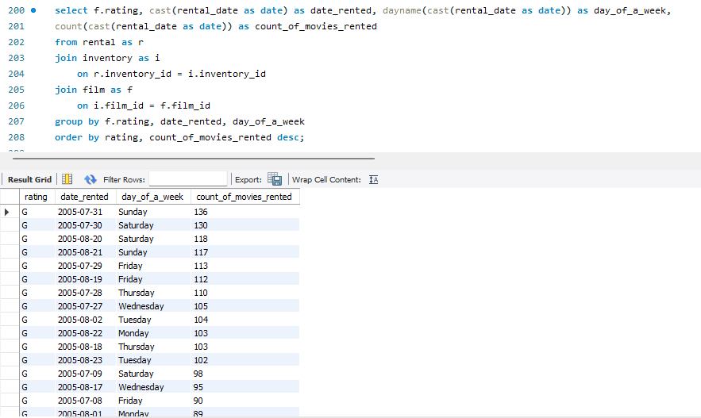

By weekday

